Experiment 1
Simulating and Comparing Network Topologies

Lab 1 Objectives:
● Understand and simulate different network topologies: Bus, Star, Mesh, and Ring.
Prerequisites: The prerequisites of this lab are-
● Basic understanding of computer networks and topology structures.
● Familiarity with network simulation tools such as Cisco Packet Tracer or NS-3.
● Basic knowledge of network communication principles.
Outcomes: By the end of this lab, students will be able to:
● Set up and simulate different network topologies.
● Identify the strengths and weaknesses of each topology.
● Compare network efficiency, reliability, and failure handling.
Description:
Simulate and compare Bus, Star, Mesh, and Ring topologies using a network simulation tool, analyze their advantages and disadvantages, and document the results.

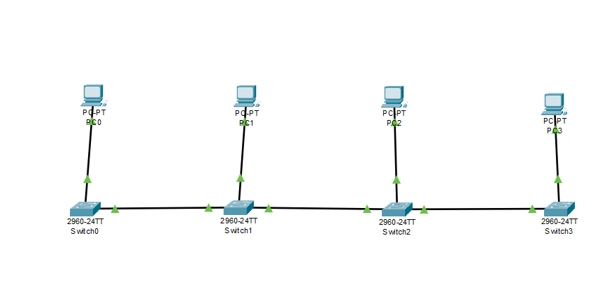
Bus Topology:
Setup

Simulation
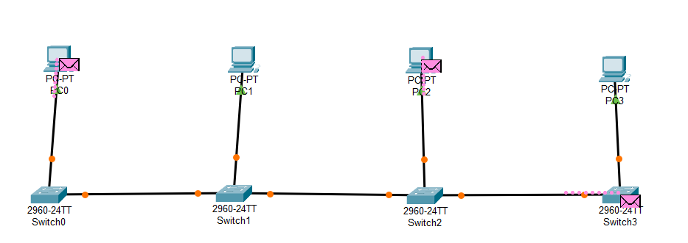

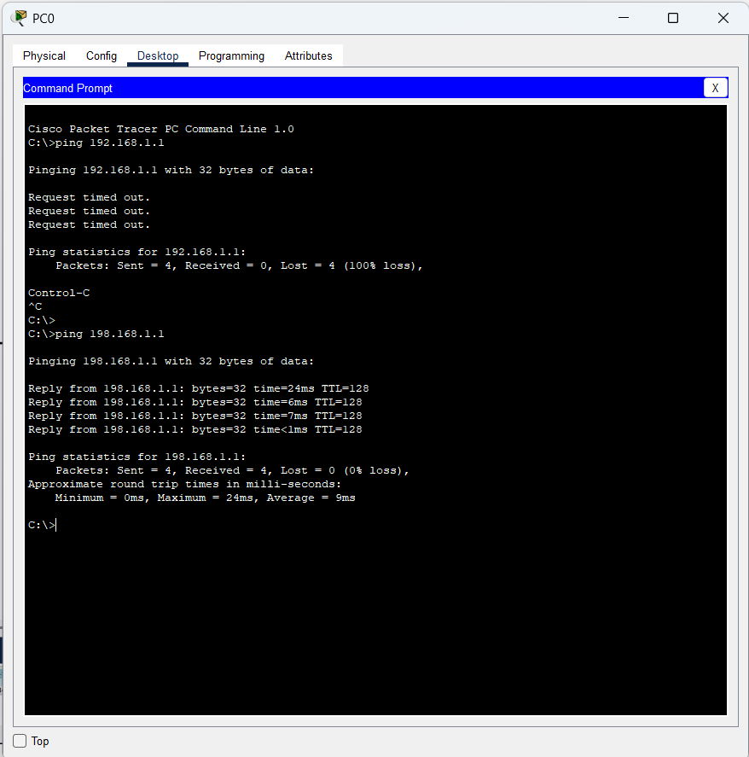
IP Addressing Test

Simulation Panel
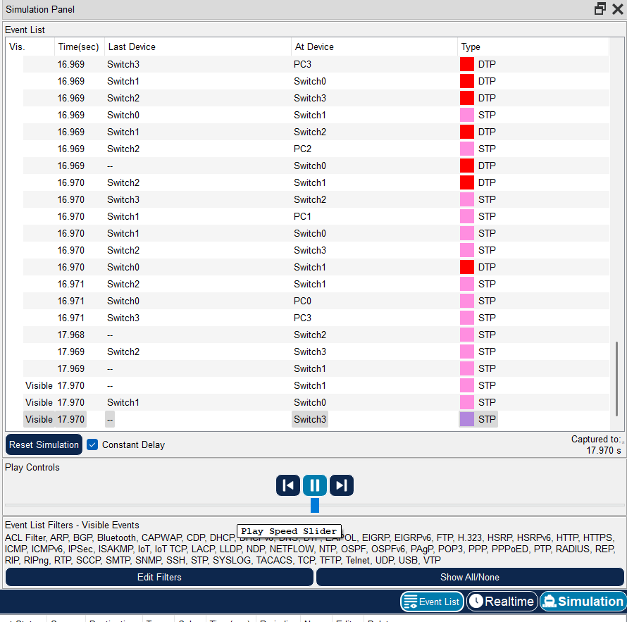

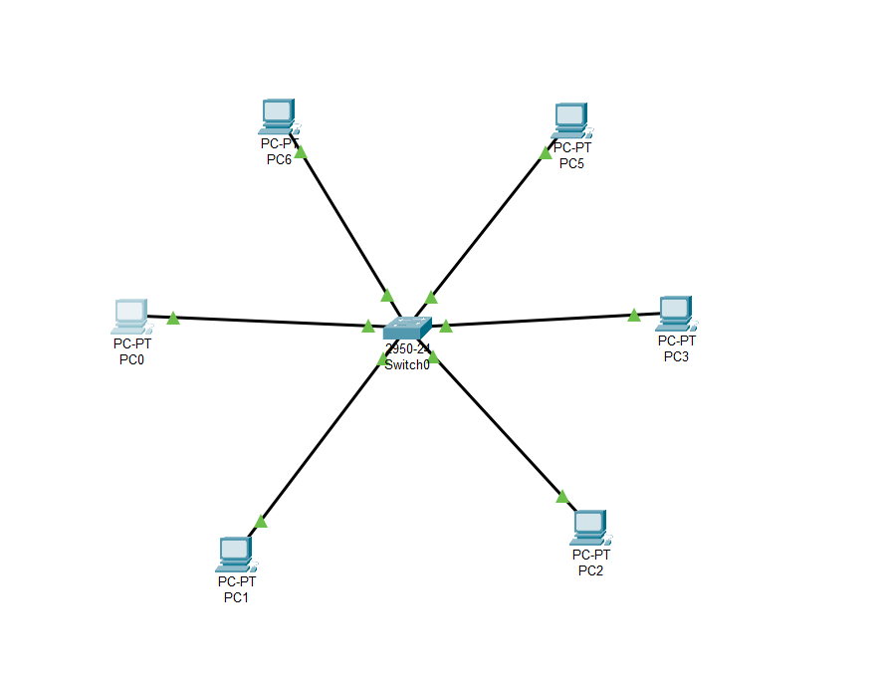
Star Topology:
Setup

Simulation
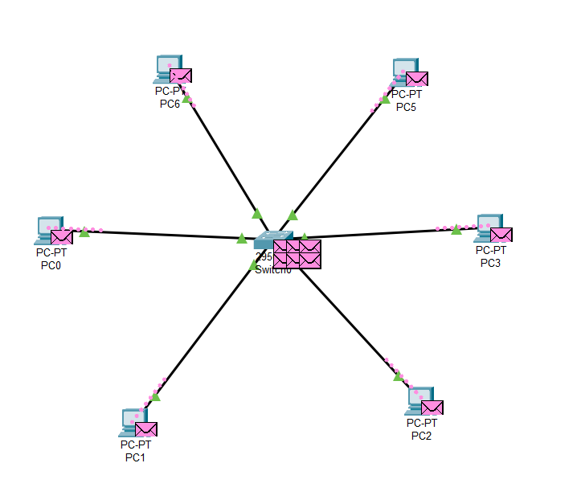
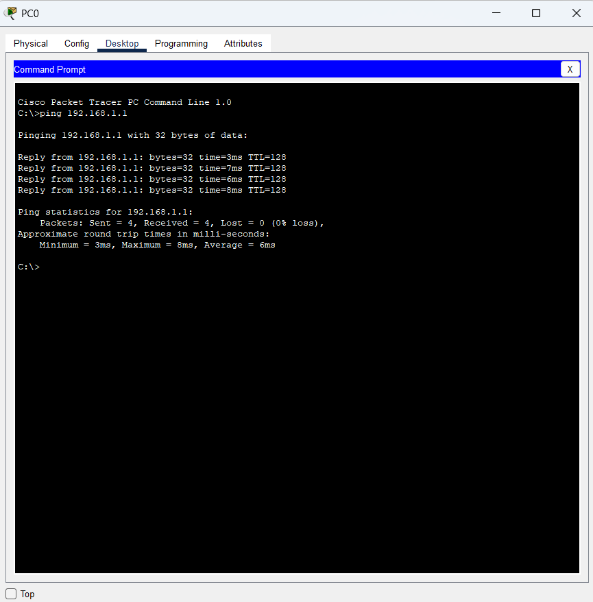
IP Addressing Test

Simulation Panel
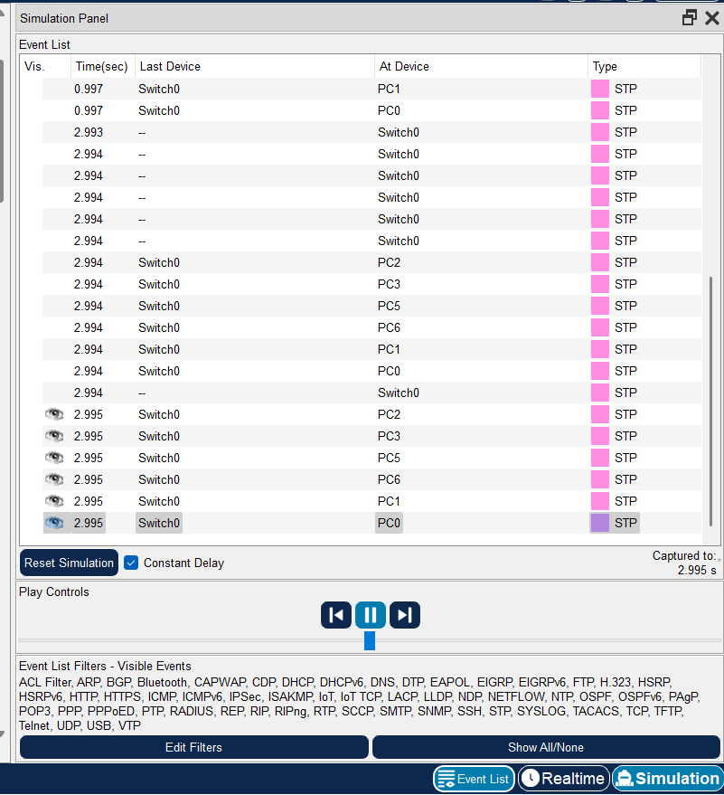

Mess Topology:
Setup

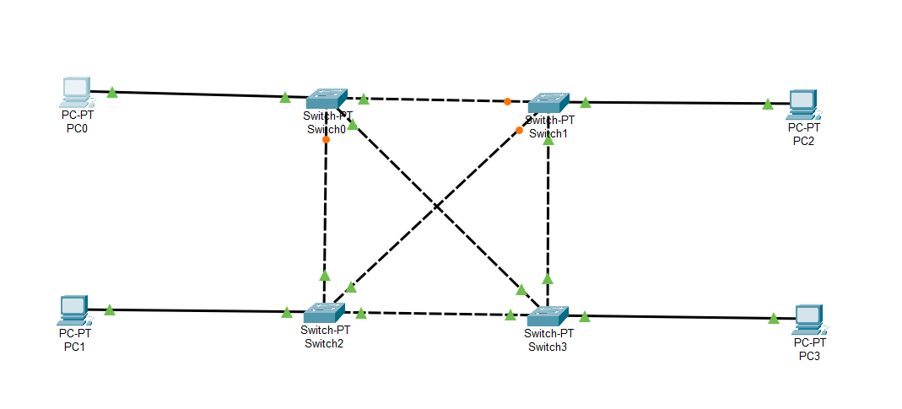

Simulation
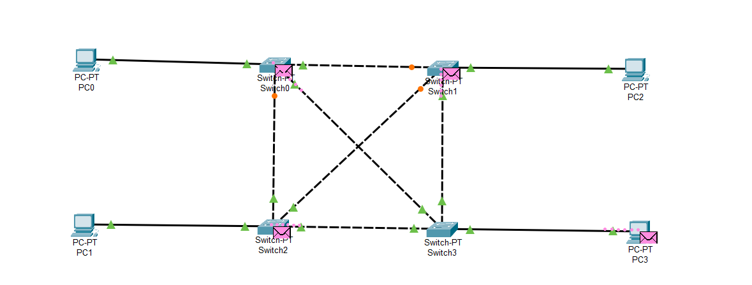
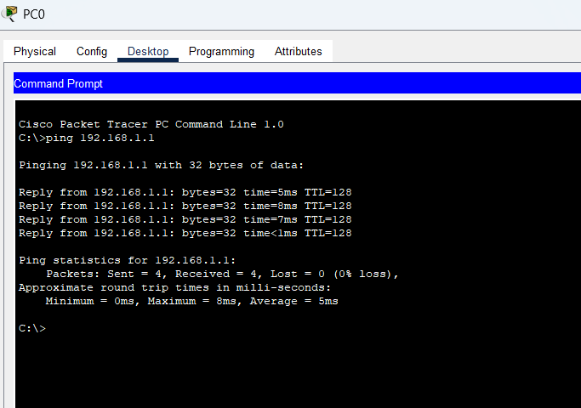
IP Addressing Test

Simulation Panel
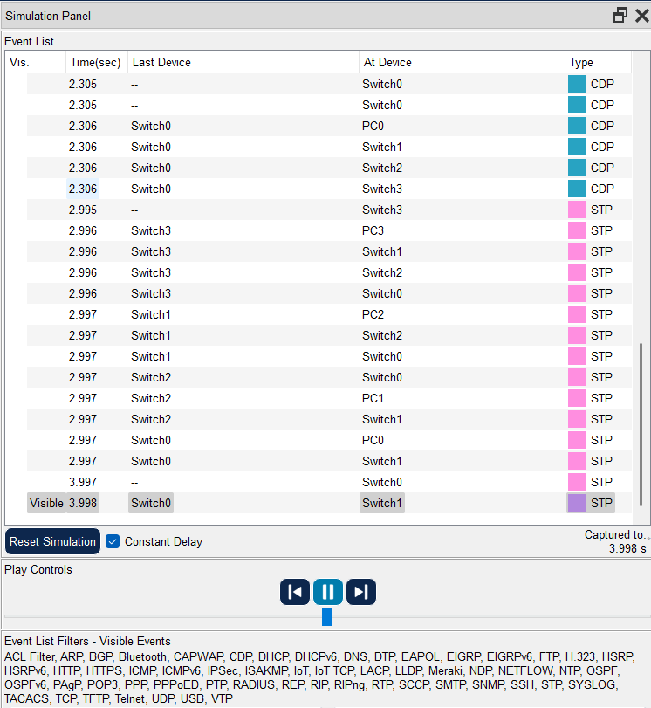

Ring Topology:
Setup

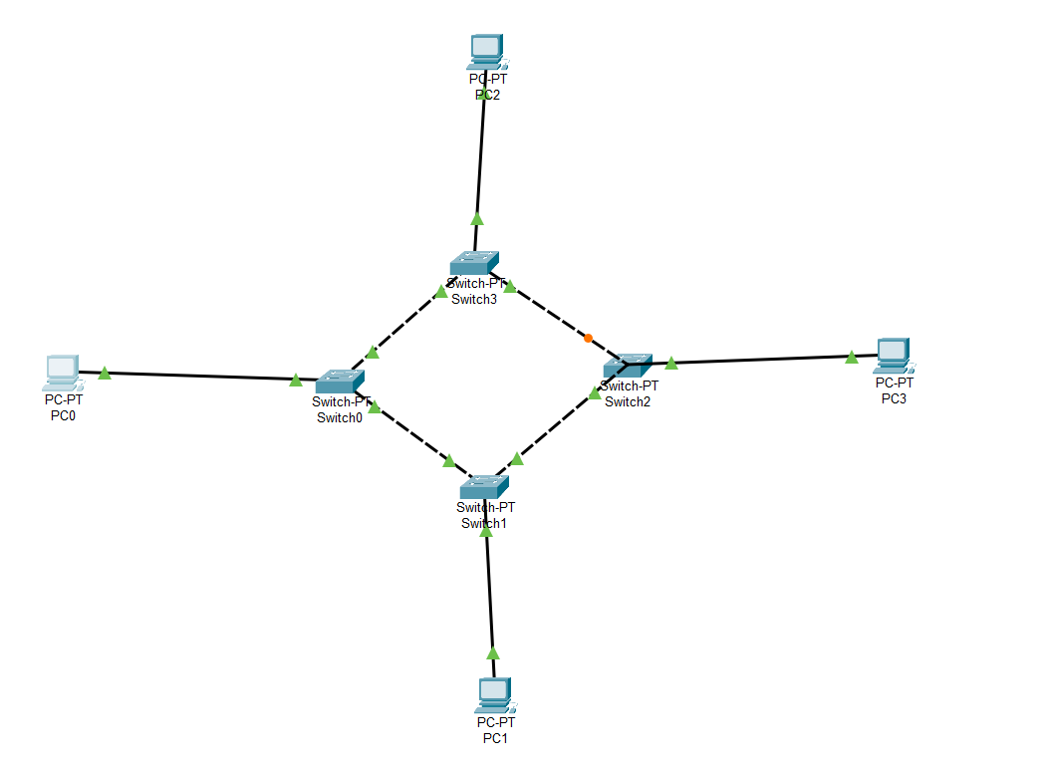

Simulation
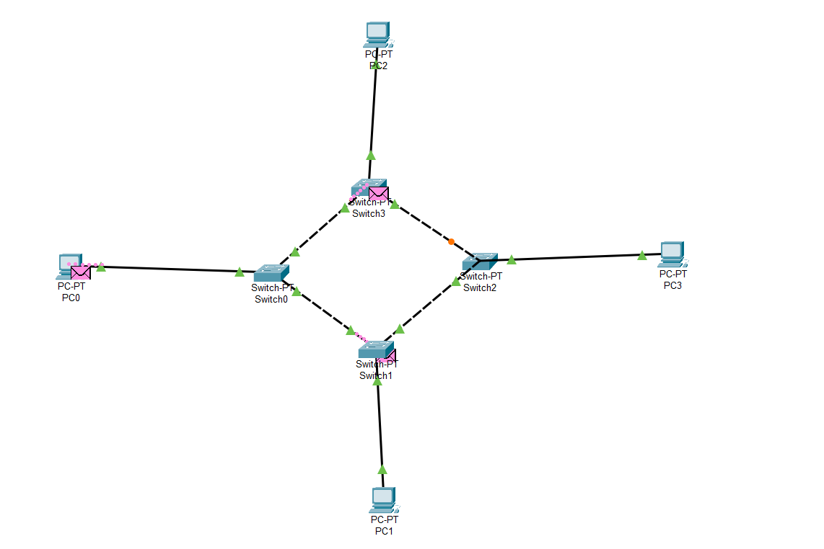

IP Addressing Test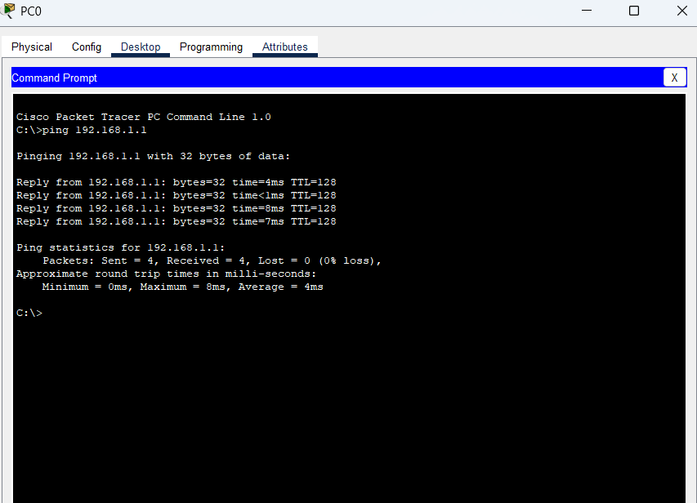
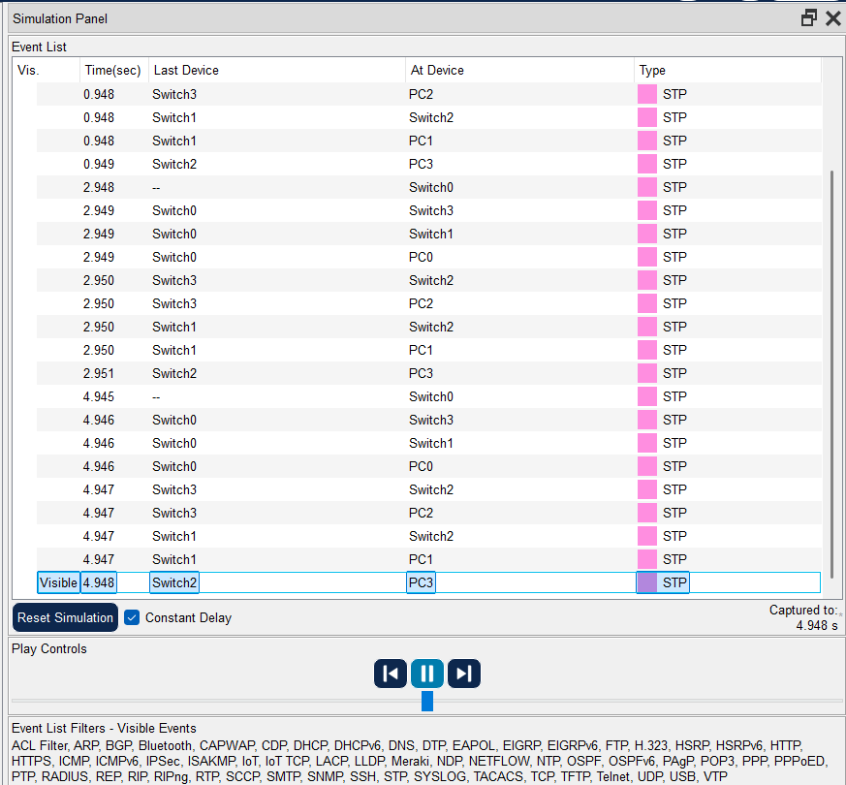
Simulation Panel

Comparison of Network Topologies
Topology | Latency (ms) | Data Transfer Speed | Failure Handling | Efficiency
Bus | Moderate | Low | Poor (single point failure) | Low
Star | Low | High | Medium (central switch failure) | High
Mesh | Very Low | Very High | Excellent (self-healing) | Very High
Ring | Moderate | Medium | Poor (loop failure) | Medium

